**HACKATHON**

DOCUMENTATION

PROJECT GROUP: -6

PROJECT NAME: - IDENTIFY CAR WASH SERVICE

|  |  |
| --- | --- |
| TEAM MEMBERS | |
| NAME | EMPLOYEE ID |
| V Rajesh Reddy | 2252148 |
| Masa Priyanka | 2252560 |
| Bhavya Pratap Singh | 2252319 |
| Mohammed Adnan | 2252149 |
| V Rajesh Reddy | 2252032 |

1. WEBSITE :

<https://www.justdial.com>

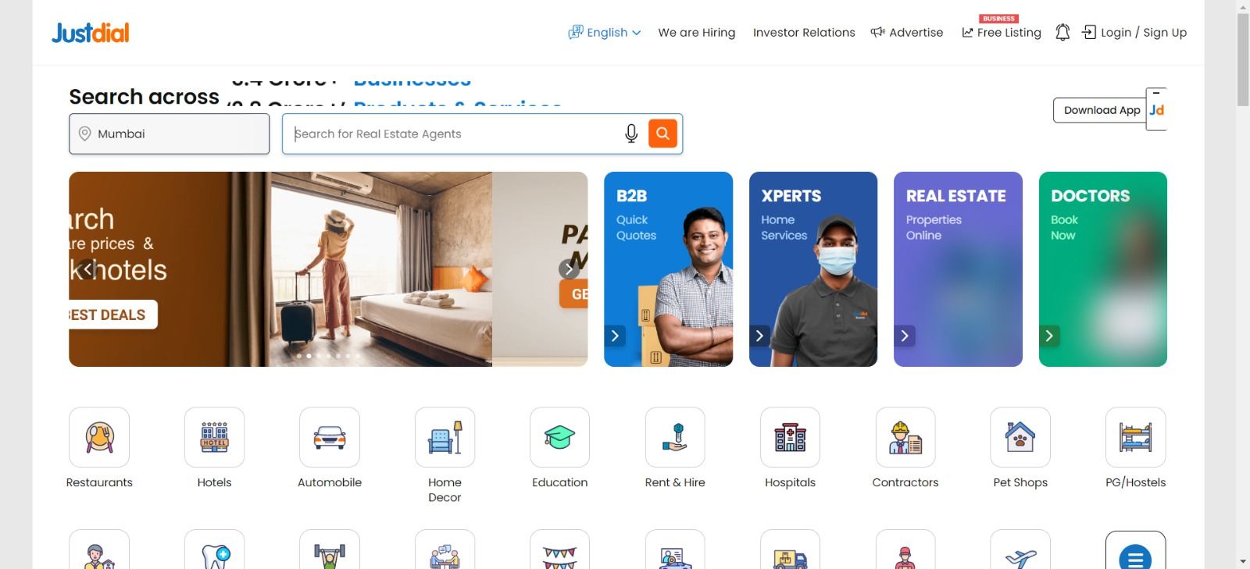

2.TOOLS & TECHNOLOGY USED: -

1. SELENIUM: - Selenium is a software testing tool for testing Web applications. It has the capability to operate across different browsers and Operating systems. Its not a tool it is a collection of automated web-based applications more efficient.

2. Eclipse: - The eclipse IDE provides better support for java developers. It is easy to use and its extended support for plug-ins. Eclipse is one of the best IDEs for java development

3.TestNG: -TestNG (Test Next Generation) is an automated framework, and which is used to manage and execute the test cases.it had a best feature is parallel execution .it has a new functionality that makes this framework more powerful and easier

1. Maven: - Maven is an automation and management build tool That helps to the developer to build their projects. that automates everything related to the building software project. Maven can also build any number of projects into a desired output like war, jar …etc.

5. Java:- Java is a High-Level Programming Language, it is a multilevel Platform and Object Oriented. Developing chatbots and other marketing tools and it is supporting Artificial Intelligence (AI) and Internet Of Things (IoT) devices.

3. WORK DONE: -

1. In The beginning we started functional testing for this we use a number of browsers and selenium. we have to create the test scenarios and test cases.

2. We use java (programming language) for the entire project application and excel sheets to take the inputs.

3. For this java-based project we required a Maven which manages to download dependencies for the project

4.EXPLANATION OF EXECUTION STEPS: -

1. Display 5 Car washing services name and phone numbers.

a. we need a browser to reach we required website.

b. Search on the your location top 5 car washing service centers.

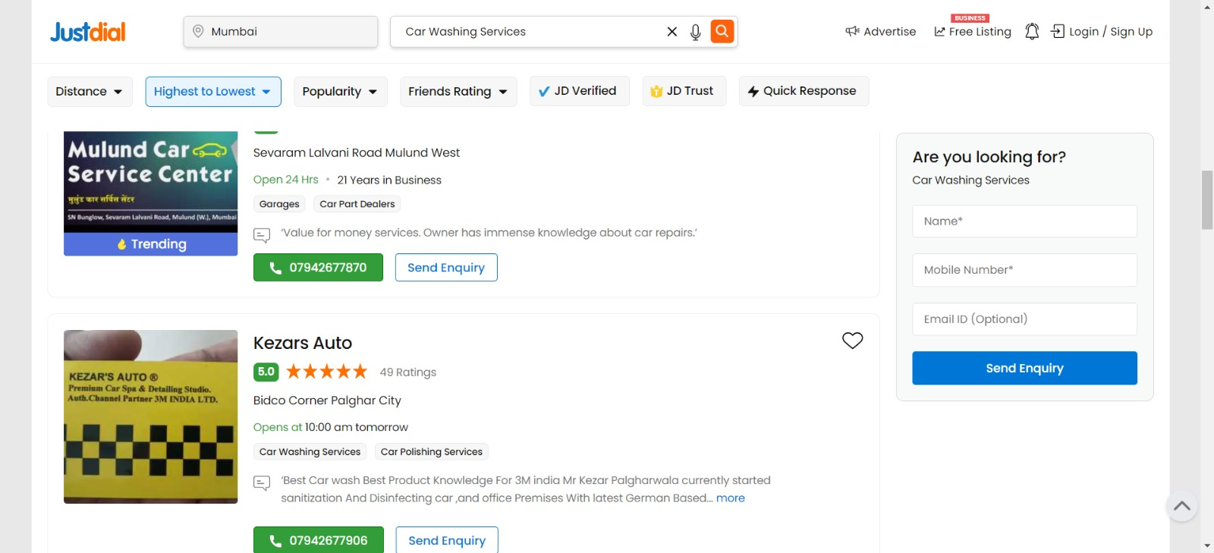

2. Register for a Free listing with invalid input.

a. Select the Free listing link

b. Fill in the details with an invalid Phone number.

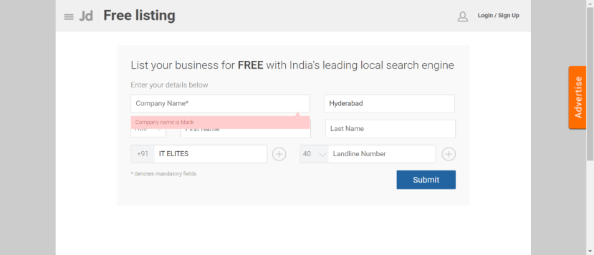

3. From Fitness, go to Gym and retrieve all sub-menu items and store in a List.

a. Go to the Menu bar and select Fitness.

b. It Stores all sub-Menu items.

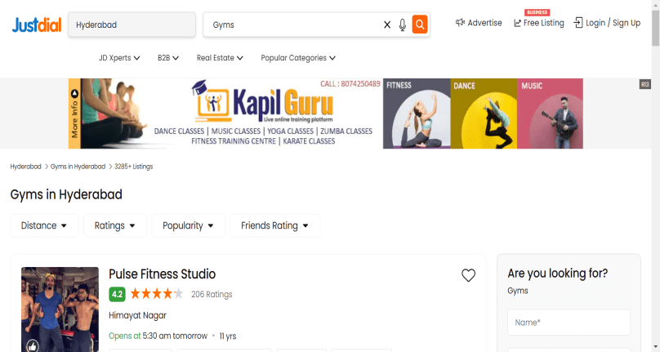

FEASIBILITY STUDIES: -

we are able to use maven and selenium to perform the required actions on the project.

AUTOMATION STEPS: -

1. Everything will be clear.

2. Move to the Maven test.

3. Now right-click on the program and select run as.

4. The automation steps will be done and then we will get the result along with captured required screenshots.